Cryptic mussels in a contact zone: towards to species distribution modelling
V. M. Khaitov, A. A. Zaychikova, P. Y. Safonov, M. V. Katolikova, M. V. Ivanov, P. P. Strelkov

Introduction
Species distribution models (SDM) being a numerical tools describing the relationship between species occurrence and environmental parameters allow to predict distribution patterns species both in space and time (Elith, Leathwick, 2009). The SDM framework is especially popular in terrestrial ecology (+++) but the amount of papers devoted to SDMs for marine species has also been increasing in recent years (Robinson et al 2017). SDMs are mostly applied for «good», morphologically distinct species (e.g. Reiss et al., 2011; Lindegren et al., 2022) that can be involved in studies which require numerous samples. The increasing evidence for cryptic species (Bastrop et al 1998; Fiser et al 2010) and polytipic species (REF) among marine animals makes it urgent to find out approaches to build SDMs for sympatric cryptic species, as well as to infraspecific taxa such as subspecies or phylogenetic lineages within polytypic species. Only few studies have been conducted in this direction so far. (e.g. Lowen et al 2019; Dennis, Hellberg, 2010).
Представление подходов, в простых словах но так чтобы не повторять что да почему до конца введения.

In the marine realm, the longest scientifically known and best studied complex of cryptic species is the blue mussel Mytilus edulis complex (Knowlton 1993, ???), which includes a number of species that are better distinguished genetically than morphologically and hybridize in sympatry (++++++). Blue mussels are powerful ecosystem engineers in the temperate and subpolar seas playing an important role in coastal communities (+++). They are also important objects of aquaculture (+++). In the North Atlantic sector, the dominant species are M. edulis (thereafter ME) and M. trossulus (MT), which form zones of sympatry (thereafter contact zones) in different corners of the region from Scotland and the Gulf of Man in the south to Greenland and Svalbard in the north (Wenne et al. 2020 and references therein). In contact zones, ME, MT and their hybrids are often found in the same samples from mussel settlements; such settlements are hereafter referred to as "mixed". Scientists generally agree that ME and MT are ecologically distinct in sympatry (RC, Katolikova et al.), and have different values in aquaculture (+++), but the data on the factors of their ecological segregation i.e. ecological niche partitioning of species is fragmentary and partly contradictory.
On a biogeographic scale, the distribution of Mytilus species is thought to be regulated primarily by temperature and its correlates (Hayhurst, Rawson, 2009; Wenne et al., 2020). Both species occur in the Arctic, but MT does not penetrate as far south to the temperate/boreal seas as ME, appearing to be a more stenothermic, cold-loving species (Wenne et al., 2020). The greatest progress in comparative ecological studies of ME and MT in sympatry has been made in the contact zones in the Baltic Sea, in the waters of the Kola Peninsula (White and Barents Seas) and in the West Atlantics.
In the Baltic, only MT inhabits the brackish areas of the inner Sea, and only ME - the more saline areas closer to the North Sea. In the contact zone in between, hybrids usually predominate in mixed settlements and the frequency of MT genes increases towards the inner Baltic (VS 11, Stuckas et al. 2017). As a result, species distribution is strongly correlated with salinity, against which the role of other factors is negligible (). Фразу что экофизиология все подтверждает со ссылкой на сраных мельцнеров?
In the Kola and West Atlantic zones the situation differs radically from that in the Baltic, which is explained by the evolutionary uniqueness of the Baltic MT (???). Hybridization is limited with less than 20% of hybrids in mixed settlements (Wenne et al. 2020). Species are distributed in space in a mosaic fashion, both in regional and local scales (RC, … ). The relationship between distribution of species and salinity is nowhere obvious (RC 05, Katolikova et al. 2016; Marchenko et al. 2023), but a number of other factors of ecological segregation have been proposed.
In the White and Barents Seas, the frequency of MT is elevated in port areas, possibly due to introduction of this species into the region with ship traffic (VS11). The only one factor of species segregation explicitly tested in the White Sea was the substrate to which littoral mussels attach (Katolikova et al. 2016). It turned out that MT is more common on fucoid algae while ME mostly lives directly on the bottom (mud, sand, stones, gravel). The non-random distribution of species across substrates, however, cannot explain the entire local-scale mosaic in their distribution (Katolikova et al. 2016). Parallel studies in the Barents Sea did not consider mussel substrates and neglected the role of predators, but verified the hypotheses of non-random distribution of species with depth. It turned out that on vertical transects, the proportion of ME increases with depth. As a result, MT appears to be a more littoral species and ME a more sublittoral one (Marchenko et al. 2023). In the western Atlantic, depth, level of anthropogenic pollution and surf exposure has been considered as possible factors in species segregation. It was hypothesized that MT may be more abundant than ME in littoral (), polluted (), and surf-exposed habitats (), but none of these hypotheses have been tested on sufficient material.

different factors have been tested in different studies and in different zones and some of these factors are collinear to each other. Ports are often located in storm-protected areas, usually in estuaries. This makes it difficult to isolate the effects of shipping and other anthropogenic factors, surf and salinity. The same could be said about the effects of depth and fouling substrate since the littoral fucoids are rare in the sublittoral. This state of knowledge is not surprising given that for most of the time of blue mussel research, scientists have used labor-intensive genotyping methods to identify cryptic species and therefore have been unable to precede large amounts of material. In addition, there were no reliable statistical methods available to model the distribution of sympatric taxa in the space of multiple factors, i.e. SDM. To our knowledge, in the history of ME and MT studies the SDM approach have been applied only twice, by Kijewski et al.(+++) and by Wenne et al. (+++). Both times the machine learning techniques were used to model the macro-geographic distribution of species (technically, of allele frequencies at taxonomically informative genes) in the space of multiple climatic and oceanographic characteristics available from public databases. The conclusions of these studies are summarized by recognizing temperature and salinity as important factors influencing the geographical distribution with MT tolerate lower salinities and temperatures than ME (Kijewski et al. Wenne et al., see also above).
Finding a simple semi-diagnostic shell trait for ME and MT - the presence or absence of a continuous prismatic strip under the ligament on the inner side of the shell (Zolotarev +++, Katolikova et al. 2016), allowed us to reliably interpret the taxonomic structure of mixed settlements without genotyping. In the White Sea ??% of MT, but only ?% of ME have a strip, and there is an equation that allows to recalculate the frequencies of “striped” morphotypes in samples into proportion of ME and MT (thereafter ME:MT ratio; equation ? in Khaitov et al., 2021). Note that hybrids are not considered as separate category under this approach.

In this study, we used the SDM approach to simultaneously assess the effects of substrate, salinity, proximity to harbors, and surf on the ME:MT ratio in the Kandalaksha Bay of the White Sea. All these factors have been proposed in previous studies as determinants of species' ecological niche partitioning in sympatry. The last of the previously discussed factors, depth, was not studied by us, but was controlled by sampling at the same littoral level. To assess the predictive value of the obtained model, we also analyzed independent testing data sets from the same Kola contact zone.

Material and methods
Study area
The 185 km long Kandalaksha Bay is funnel-shaped. The bay has many islands and skerries, and its coastline is highly indented (Fig. 1). Climate is continental subarctic with 4-5 months of ice cover and the average monthly sea surface temperature in August of 13.8°C. Mean tidal range is 2 m. Summer surface salinity is 24 ppt throughout most of the Bay, but is lower in the estuarine areas of the rivers (REF). 24 rivers and two hydropower canals with a catchment area of 141 - 12830 km2 flow into the Bay, with the largest river, the Niva, entering the Bay at its very top (see Stable? for ??? information). Due to the complex geometry of the shoreline and numerous rivers, local surf and salinity gradients are pronounced (Fig 1a, b).
Historically (through the 20th century), six ports were functioning in the Bay operating oceanic vessels (Fig. 1). Two of these ports, both in the top of the Bay, are still functioning while the remaining are abandoned (Sailing directions of the White Sea, 1932; Krasavtsev, 2011) but still visited by small ships, according to the common knowledge.
Mussels are ubiquitous and abundant on the littoral, particularly in the fucoid algal belt (depth range ... ), consisting mainly of Fucus vesiculosus and Ascophyllum nodosum.
Mussel sampling and processing
Between 2011 and 2018, mussels were sampled at 95 sites within the littoral fucoid belt. Sites were chosen to describe littoral populations in the Bay in as much detail as possible and to account for the heterogeneity of their habitat in terms of substrate, surf exposure, and distance from rivers and harbors, but to minimize differences in depth. At each site, three samples from fucoid thalluses (hereinafter, algal samples) and three samples from bottom substrates (bottom samples) were collected in few meters from each other using 0.025 m2 and 0.5 m2 frames, respectively.
The procedure for selection and counting of mussels from samples taken from different substrates was different. From the bottom samples, all mussels were selected, counted, weighted to the nearest g (total weight) and used in further analyses. From algal samples, one bunch of algae (selected so that to contain few dozens of mussels), and all other algae were weighed separately, along with attached mussels. Only mussels from the bundle were selected, counted and used in further analysis. To predict the total number of mussels in the sample, the weight of the bundle with the known number of mussels and the rest of the algae was compared. For 12 sites the information on density of mussels in algal samples was lacking, and these sites were excluded from those analyses which required data on mussel abundance.
Shell morphotypes (i.e. mussels with and without of a continuous prismatic strip under the ligament) were identified for all mussels larger than 10 mm in length from bottom samples and subsamples from algal samples as in Khaitov et al. 2021. For further, the frequencies of morphotypes in each sample was converted to the proportion of MT (ME:MT ratio ) Ptros using the equation ? from Khaitov et al. 2021.
По поводу карты. Предлагаю блок на страницу с 4 картами, показывающими мозаичность по солености, прибойности, ptros на фукусах и ptros на грунте (в основном сете). Где-то можно радиусы с расстояниями от портов поставить. Дополнительный - в приложение.
Environmental parameters assessment
In total, we used six parameters describing possible influence of rivers, ports, surf and type of substrate on mussels (Table ?). Salinity was measured using an “Atago S/Mill-E” refractometer. To calculate Fetch as a proxy of surf exposure, the R-package “windfetch” was used (Seers, 2022). To classify rivers by size (RiverSize), the data on catchment areas from the ESM? was used. We used three different measures of river influence, believing that a single estimate of salinity at low tide (Salinity) may not be sufficient to characterize salinity per se, and more generally the extent of estuarine conditions at the sampling sites.
Environmental parameter/ model parameter | Type of predictor | Explanation | Range (median) in the data
Type of substrate
Substrate | Categorical, algae vs bottom | Algal and bottom samples are treated separately | NA
Influence of rivers
Salinity | Continuous | Surface salinity at the time of sampling (i.e. at low water). | 2-30 (19) ppt
MinDistRiver | Continuous | The straight line distance between the site and the nearest river mouth by map | ?-? (??) km
RiverSize | Categorical, small vs large | Rivers are categorized according to whether their catchment area is larger or smaller than the median area of all rivers. | NA
Influence of ports
MinDistPort• | Continuous | The straight line distance between the site and the nearest port by map | 0.1 – 82.0 (18.7) km
PortStatus | Categorical, active vs abandoned | Ports are categorized according whether they are active or abandoned | NA
Influence of surf
AverageFetch | Continuous | The unobstructed length of water over which wind from a certain direction can blow over, by map; values are averaged over the four cardinal directions | ??-?? (??) km

Results

Environmental parameters in the Kandalaksha Bay
Two of six ports presented in the area were active at the date of material collection (Fig. 1 A, STable ++ SEM). The distance from sampling sites to the nearest ports ranged from 0.11 to 82 km (Median = 18.7 km) (SFig ++, A). Sites visually categorized as “Sheltered” on average were characterized by lower values of wind fetch than those categorized as “Exposed” (SFig. ++, B). The most exposed sites (maximum values of wind fetch) were located on the western coast of the Kandalaksha Bay, and on the open shores of the islands at the top of the bay (Fig. 1 A). Salinity measured at the time of sampling ranged from 2 to 30 ppm (Median = 19 ppm). The most desalinated areas were the top of the Bay and inlets where rivers flow into (Fig. 1 A). Salinity at sites situated close to “Large” rivers was lower than at sites closer to “Small” ones (SFig. ++, C). Salinity tended to increase with increasing of distance to the mouth of the nearest river (SFig. ++ D) but no association between distance to the nearest port and salinity was found (SFig. +++ E). Sites situated close to ports tended to have lower wind fetch (SFig. +++ F). All correlations between salinity, distance to the nearest river mouth, distance to the nearest port and wind fetch were rather low (STable +++). The largest correlation revealed was between wind fetch and distance to nearest port (r = ++).

Ptros spatial distribution in the Kandalaksha Bay
The maximum Ptros was observed in the top of the Kandalaksha Bay itself and in the small bays deeping into the mainland (Fig. 2). At the same time, sites with a lower Ptros were located in the immediate vicinity of sites where high Ptros values were represented (Fig. 2), reflecting the high variation of taxonomical structure in small spatial scale. Settlements with the lowest Ptros were represented in the open areas of the North-West coast.
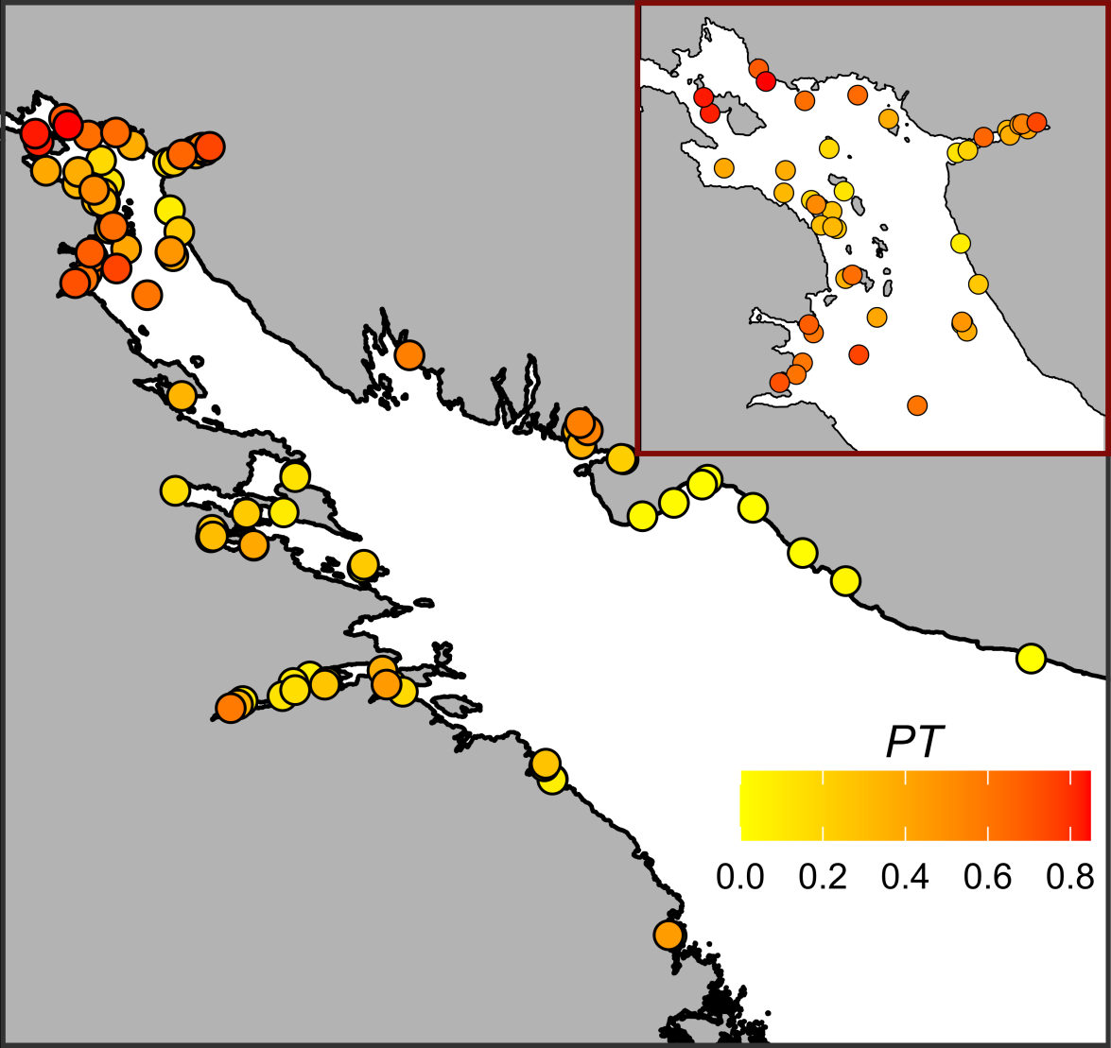 At! Надо доделать рисунок, заменить легенду.

Relationship of Ptros to environmental parameters
The values of VIF calculated for the predictors’ set included in the analysis were rather small (the maximal VIF was detected for Fetch: 1.76). Although some pairwise correlation between environmental factors were found (see above) the low VIF values can be interpreted as a negligible collinearity between predictors (i.e. they don’t mask influence of each for other).
To assess the dependency of PT on all predictors considered we constructed the Model 1 (Table 1, R² = 0.71) which explained 77% of total deviance. The Model 1 revealed statistically significant dependency of Ptros on all predictors except one.
The effective degrees of freedom (edf, Table 1) for most smoothers were equal to 1, reflecting the linear dependence of PT on such continuous predictors as distance to the nearest port (MinDistPort) and fetch (AverageFetch). The exception was Salinity, where a pronounced curvilinear dependence was revealed.
Table 1 . Parameters of smoothers and coefficients of parametric terms for the Model describing dependency of Ptros on predictors.
Model term | edf | ref.edf | Chi.sq | p-value
s(Salinity) | 2.4 | 9 | 396.7 | 0.0033
s(DistRiver) | 0.0 | 9 | 0.0 | 0.6724
s(Fetch) | 0.9 | 9 | 88.2 | 0.0417
s(DistPort) | 1.0 | 9 | 276.2 | 0.0016
Random effect s(Site) | 74.4 | 92 | 453.6 | 0.0000
Model term | Parameter estimate | SE | z-statistic | p-value
(Intercept) | -1.7 | 0.1 | -11.8 | 0.0000
Substrate(Algae) | 0.9 | 0.1 | 14.6 | 0.0000
RiverSize(Large) | 0.4 | 0.2 | 2.6 | 0.0091
PortStatus(Active) | 1.0 | 0.2 | 5.7 | 0.0000
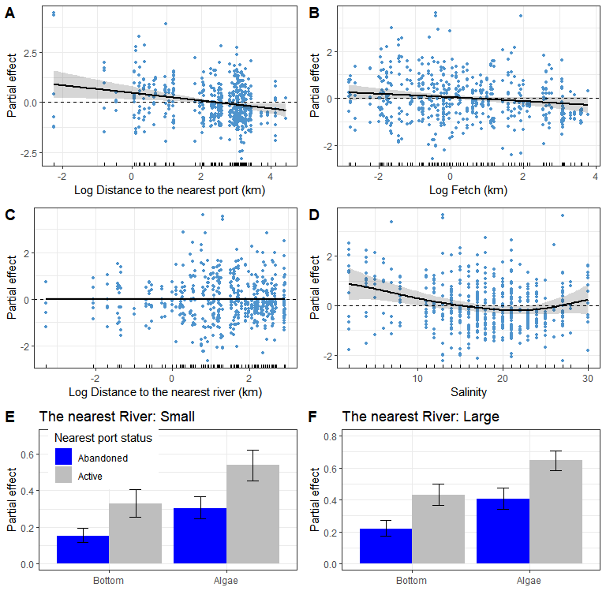
Fig. 3. Predictions of the Model 1 describing the dependency of Ptros on distance to the nearest port (A), average fetch (B), distance to the nearest river (C), salinity (E) and substrate type, nearest port status and size of the largest river (E, F). The gray ribbons and wiskers demonstrate 95% confidence interval. The dotted horizontal lines in panels A-D represent the zero smoother’s value. Points on panels A-D reflect partial residuals but not raw data for each sample.
Возможно, что для лучшей визуализации надо пересчитать шкалу OX из логарифма в обычные занчения. Это не лучший ход, но можно, если так трудно.
According to the Model 1 (Table 1, Fig. 3) Ptros has a tendency to decrease with increasing of distance to the nearest port (Fig. 1 A). The nearest port status had also significant influence on Ptros: the value was higher when port status was “Active” (Fig. 3 E, F). The dependency of Ptros on fetch (Fig. 3, B) was negative. No significant association between Ptros and the distance to the neares river was was found (Table 2, Fig 3 C).
The curvilinear dependence of Ptros on salinity (Fig. 3, D) can be described as follows. The predicted value of Ptros decrease when salinity moving from minimal values to apr 20-22% when it reached minimum. When salinity increases after this point the Ptros value increase as well. However, at low (less than 15 ppt) and high (more than 27 ppt) salinity, Ptros becomes higher than zero. This low and high salinity (when the Model 1 predicts Ptros higher than zero) was observed at 28 and 8 sites respectively (Fig. 1 B). For other 59 sites, with intermediate salinity, predicted Pros was less than zero (Fig. 3 D). All low salinity sites were represented in the top parts of different inlets (Fig. 1 B) but no clear pattern revealed in the distribution of sites with high salinity (Fig. 1 B).
According to the Model 1 the value of Ptros is dramatically higher on the Algae substrate than on the Bottom one (Table 1, Fig. 3 E, F). This value is higher in those sites which is close to active ports than to abandoned ones. Finally, the Ptros value is slightly higher at sites situated close to large rivers than to small ones.

Dependency of Ptros on substrate type
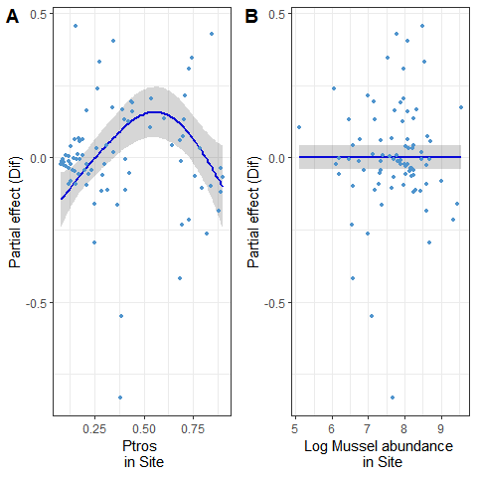
Fig. 4. The dependence of difference between PT on Algae and Bottom subatrates on Ptros_{Site} (A) and total mussel abundance (B).
The difference between Pros on Algae and Bottom substrates was significantly dependent on Ptros in site (STable +, Fig. 4 A). The dependency revealed was curvelinear (edf = 2.7, STable +) with minimal Dif values close to zero in sites with minimal and maximal values of Ptros_{Site}. The maximal Dif values were associated with intermediate Ptros_{Site}. This pattern reflect the prevalence of MT at Algae substrate and prevalence of ME at Bottom substrate in those sites where both morphotypes are presented in equal amount. No significant dependency was revealed with total absolute mussel abundance (STable +, Fig. 4 B).

Assessment of model’s predictive power
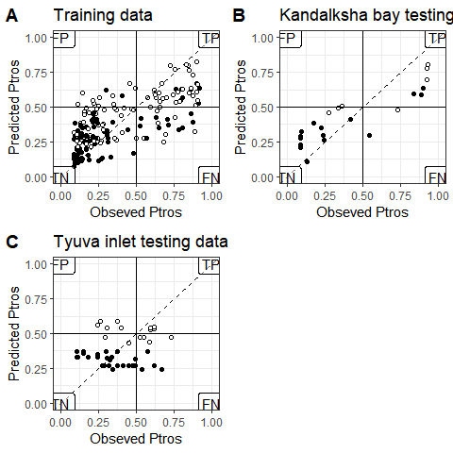
Fig. 5. Comparison of PT-values predicted by Model 2 and obsreved proportion of T-morphotype for Bottom (black circles) and Algae (white circles) samples. The horizontal and vertical solid lines reflects the boundary between MT- and ME-dominated sites. Dotted lines represent the position of perfect fit when observed and predicted values are equal. Labels in the plot corners mark the quadrants with false positive (FP), true positive (TP), true negative (TN) and false negative (FN) predictions.
We plotted values predicted by the Mode 1 against observed ones (Fig. 5).The diagram constructed for training dataset reveal relatively good correspondence between predicted and observed Ptros. The AUC value was rather high (AUC = 0.87) It is important to note that the most false positive preditcions for main, training, data set were made for Algae samples whereas false negative predictions were made both for Algae and Bottom samples.
In the case of testing dataset from the Kandalaksha bay (Fig. 1 B) the most sites were correctly classified by the Model 1. The AUC for this data was close to 1 (AUC = 0.92) indicating high predictive ability of the Model 1. This model being applied to testing dataset from the Tyuva inlet diplay lesser predictive power (AUC = 0.66). Only few samples were classified as true positive and the most of them were classified as true negative. All false positive samples were associated with Algae bat equal numbers of Algae and Bottom samples were in false negative region.

Discussion
–>
–>
–>

Literature cited
Лоция Белого моря / Гидрографическое управление ; общ. ред. А. Н. Рождественского. – 5-е изд. – Ленинград : Издание Гидрографического управления, 1932. – LXXII, 566 с., 22 вкл. л. ил., карт., схем.

Supplementary electronic materials (SEM)
–>
–>

